**ASSIGNMENT 4**

|  |  |
| --- | --- |
| **DATE** | 8th November 2022 |
| **ROLL NUMBER** | 2019503557 |
| **NAME** | J.V. SANJIV PRAKASH |
| **TEAM ID** | PNT2022TMID35662 |

1. **Pull an Image from docker hub and run it in docker playground.**

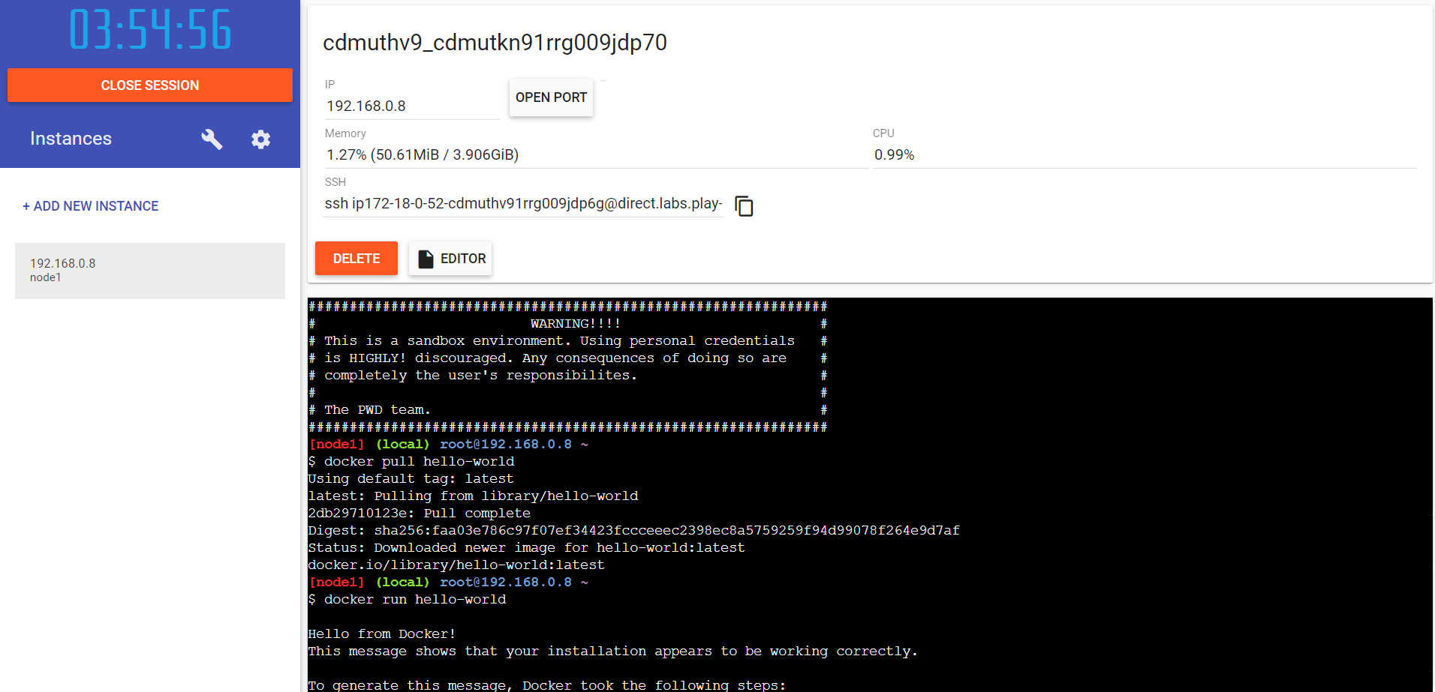

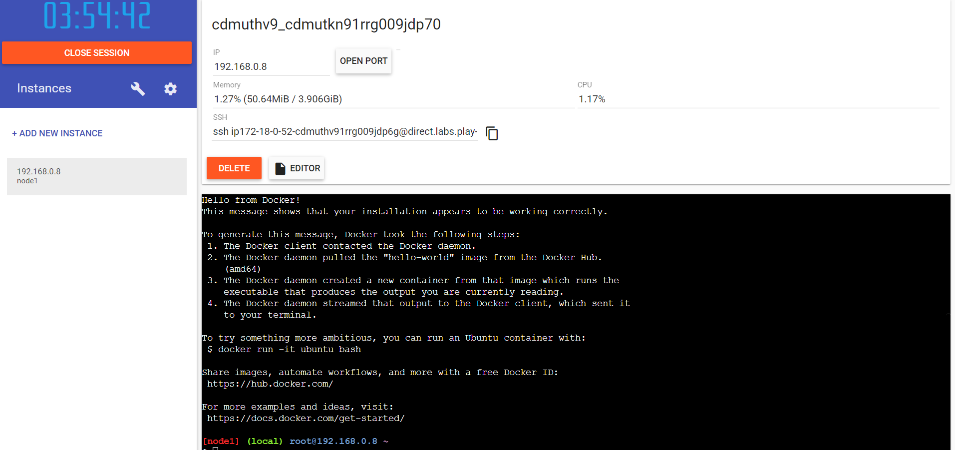

1. **Create a docker file for the jobportal application and deploy it in Docker desktop application.**

**Docker File:**

FROM python:3.6

COPY . /app

WORKDIR /app

RUN pip install -r requirements.txt

EXPOSE 5001

ENTRYPOINT [ "python" ]

CMD [ "main.py" ]

**OUTPUT**

Docker file created and deployed in docker desktop application.

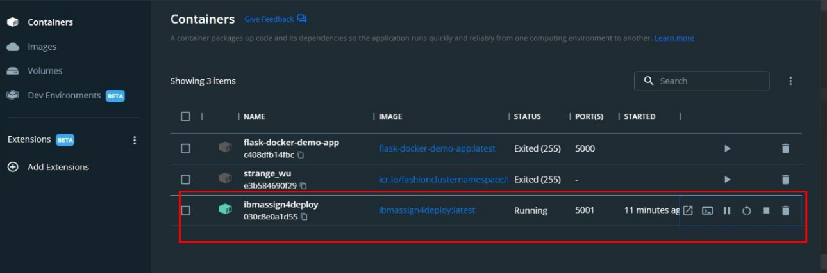

1. **Create a IBM container registry and deploy helloworld app or jobportalapp.**

**OUTPUT**

IBM container registry is created and app is deployed.

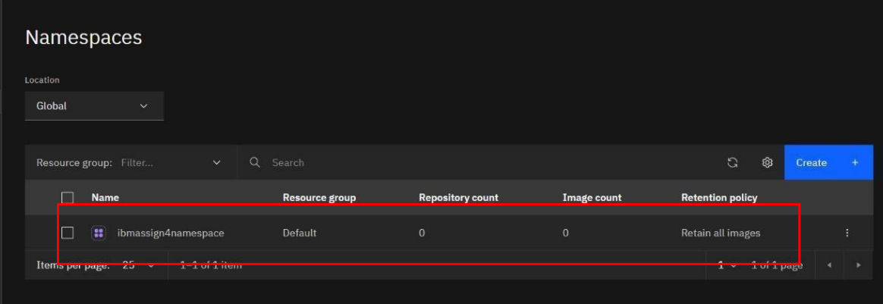

1. **Create a Kubernetes cluster in IBM cloud and deploy helloworld image or jobportal image and also expose the same app to run in nodeport**.

Kubernetes cluster is created and app is running at node.

